**Q1 (15 marks): Please find, read, and summarize the following patent. Write one page that clarifies and connect it to the concepts taught in the course, including virtual fixture, surgical semiautonomy, human-robot collaboration. Also, mention how this invention can augment human motion performance.**

<https://patentimages.storage.googleapis.com/2a/b5/ee/5607204fb3544e/US8010180.pdf>

The given patent was filed by Arthur Quaid et al., Hollywood, FL, on 21st February, 2006 and published on 29th June, 2006.

The patent describes a surgical device with an on board computer system to provide haptic guidance to the surgeon. The computer system on the device is configured to maintain control parameters for controlling the surgical instrument and guide the user using haptic technology to limit the user’s manipulation of the device. The computer system is guided by the relationship between the anatomy of the patient, and at least one of a position, an orientation, a velocity and an acceleration of a portion of the surgical device. Movements in the anatomy of the patient during the procedure will lead to an adjustment in the control parameters of the device.

**, including virtual fixture**

*A haptic object may be customized to include any desired shape. Such as, for example, anatomically contoured implant shapes, protective boundaries for sensitive structures (e.g., intra-articular anatomy), image-derived tumor boundaries, and virtual fixtures for in vivo assembly of implant compo US 8,010, 180 B2 31 nents. In one embodiment, the haptic object may be uniquely contoured to matcha disease state of the patient. For example, the haptic object may define a virtual cutting boundary that encompasses only diseased bone. Thus, the haptic object can be used to guide the user in removing the diseased bone while sparing healthy Surrounding bone. In this manner, the Surgical system 10 enables the user to sculpt bone in a customized manner, including complex geometries and curves that are not possible with conventional cutting jigs and saw guides. As a result, the Surgical system 10 facilitates bone sparing Sur gical procedures and implant designs that are Smaller in size and adapted for a patient's unique disease state.*

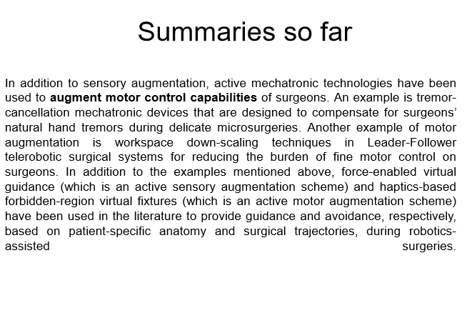

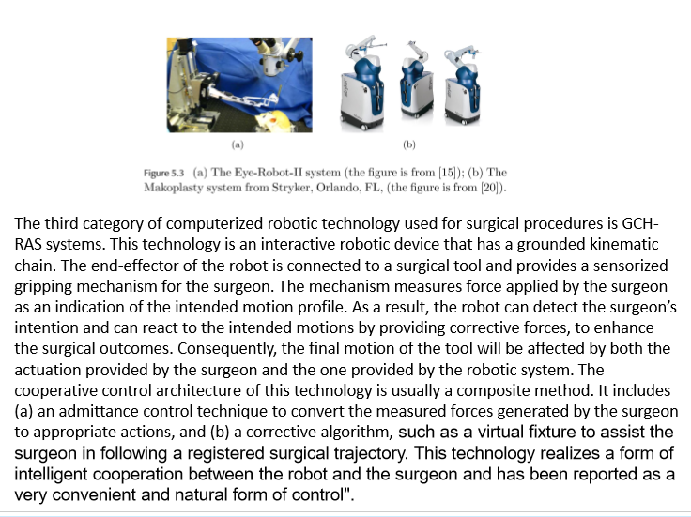

**surgical semiautonomy**

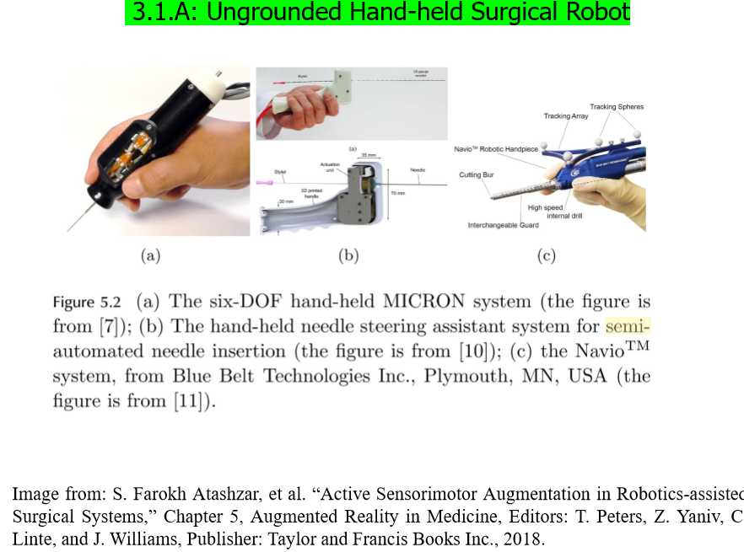

*Another advantage of the haptic device 30 is that the haptic device 30 is not intended to move autonomously on its own. In contrast, autonomous Surgical robotic systems used for ortho pedic joint replacement perform bone cutting autonomously with a high speed burr. Although the Surgeon monitors progress of the robot and may interrupt if necessary, the US 8,010, 180 B2 19 surgeon is not in full control of the procedure. With the haptic device 30, however, the surgeon (as opposed to the robot) manipulates the tool 50. Thus, the Surgeon maintains control of the cutting operation and receives only guidance or assis tance from the haptic device 30. As a result, the surgeon is not required to cede control to the robot of the haptic device 30, which increases the Surgeon’s comfort level during the pro cedure.*

**human-robot collaboration**

*In operation, the computing system 20, the haptic device 30, and the tracking system 40 cooperate to enable the surgi cal system 10 to provide haptic guidance to the user during a Surgical procedure. The Surgical system 10 provides haptic guidance by simulating the human tactile system using a force feedback haptic interface (i.e., the haptic device 30) to enable the user to interact with a virtual environment. The haptic device 30 generates computer controlled forces to convey to the user a sense of natural feel of the virtual envi ronment and virtual (or haptic) objects within the virtual environment. The computer controlled forces are displayed (i.e., reflected or conveyed) to the user to make him sense the tactile feel of the virtual objects. For example, as the user manipulates the tool 50, the surgical system 10 determines the position and orientation of the tool 50. Collisions between a virtual representation of the tool 50 and virtual objects in the virtual environment are detected. If a collision occurs, the Surgical system 10 calculates haptic reaction forces based on a penetration depth of the virtual tool into the virtual object. The calculated reaction forces are mapped over the virtual object surface and appropriate force vectors are fed back to the user through the haptic device 30. As used herein, the term “virtual object” (or “haptic object) can be used to refer to different objects. For example, the virtual object may be a representation of a physical object, Such as an implant or Surgical tool. Alternatively, the virtual object may represent material to be removed from the anatomy, material to be retained on the anatomy, and/or anatomy (or other objects) with which contact with the tool 50 is to be avoided. The virtual object may also represent a pathway, a guide wire, a boundary, a border, or other limit or demarcation.*

**Also, mention how this invention can augment human motion performance.**

*Dexterity of the arm 33 may be enhanced, for example, by adding additional degrees of freedom. For example, the arm 33 may include a wrist 36. As shown in FIG. 2A, the wrist 36 may be disposed on the arm 33 (e.g., at a distal end of the third segment 33c) and includes one or more degrees of freedom to augment the degrees of freedom DOF DOF DOFs, and DOF of the arm 33. For example, as shown in FIG. 2B, the wrist 36 may include a degree of freedom DOFs. In one embodiment, the wrist 36 includes two degrees of freedom, and the degree of freedom DOFs of the arm 33 is eliminated. The wrist 36 may also be a one degree of freedom or a three degree of freedom WAMTM wrist manufactured by Barrett Technology, Inc.*

*In one embodiment, once the anatomy trackers 43a and 43b are attached, a range of motion (ROM) of the knee joint is captured (e.g., by moving the knee joint through the ROM while tracking the anatomy trackers 43a and 43b with the tracking system 40). The captured ROM data may be used to assess relative placement of the femoral and tibial implants. For example, the ROM data augmented by registration of the physical patient to the preoperative image data allows the user to plan relative implant positions consistent with a current condition of the patient’s soft tissue (e.g., based on disease state, age, weight, current ROM, etc.). In one embodiment, implant depth can be planned so that the installed implants fill the pre-existing joint gap (i.e., the gap existing preoperatively between the tibia T and the femur F) in the knee of the patient. In addition, other important parameters such as, for example, adequate contact, anterior and posterior coverage, and proper relative rotation of the implant pair can be evaluated through out the ROM of the knee joint. In this way, comprehensive placement planning for both implants can be performed before cutting any bone.*

**Q2 (15 marks): Please find, read, and summarize the following paper. Write one page that clarifies your “main observations and findings”**

**Q3)**

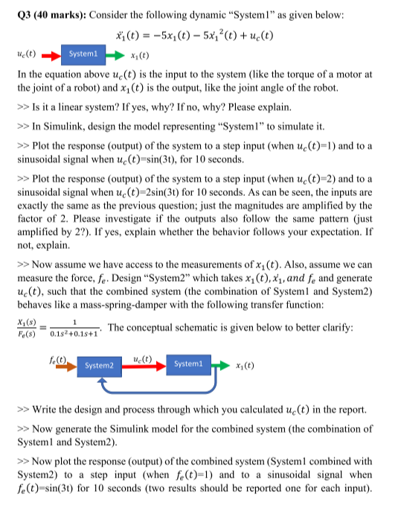

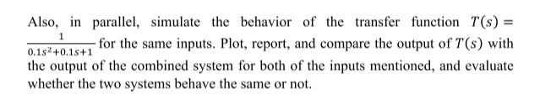

1. **Is it a linear system? If yes, why? If no, why? Please explain.**
2. **In Simulink, design the model representing System1 to simulate it.**
3. **Plot the response (output) of the system to a step input (when =1) and to a sinusoidal signal when u=sin(3t), for 10 seconds.**
4. **Plot the response (output) of the system to a step input (when sinusoidal signal when**

**=2) and to a =2sin(3t) for 10 seconds. As can be seen, the inputs are**

**exactly the same as the previous question; just the magnitudes are amplified by the factor of 2. Please investigate if the outputs also follow the same pattern (just amplified by 2?). If yes, explain whether the behavior follows your expectation. If**

**not, explain.**

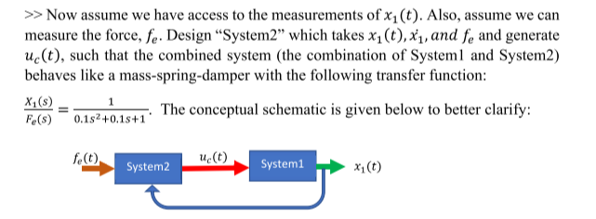

1. **Write the design and process through which you calculated in the report.**
2. **Now generate the Simulink model for the combined system (the combination of System1 and System2).**
3. **Now plot the response (output) of the combined system (System1 combined with System2) to a step input (when=1) and to a sinusoidal signal when =sin(3t) for 10 seconds (two results should be reported one for each input)**
4. **Also, in parallel, simulate the behavior of the transfer function for the same inputs. Plot, report, and compare the output of with the output of the combined system for both of the inputs mentioned, and evaluate whether the two systems behave the same or not.**

**Q4)**

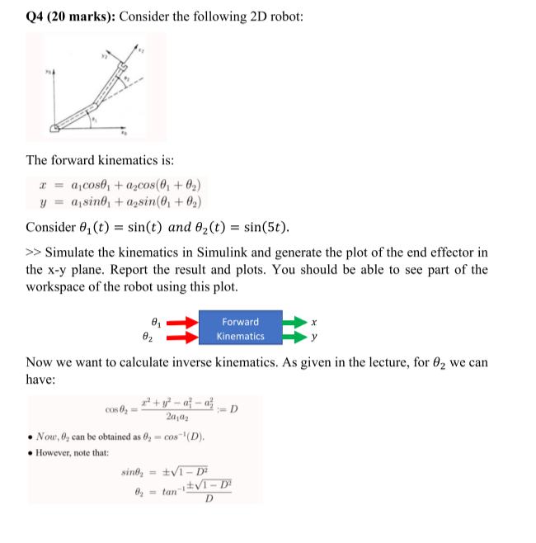

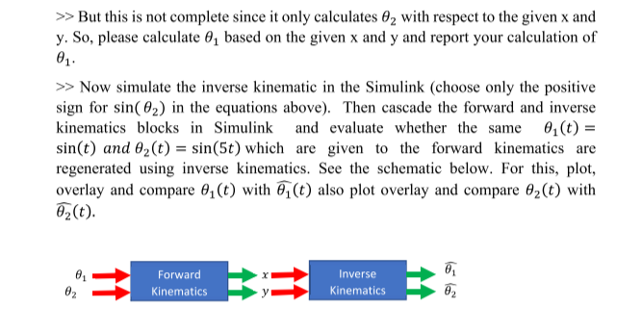

**Q5)**

